**Low Latency Calibration of In-Space Data**

Ewan Dickson, Richard Schwartz Version 1.0   
Univ. Graz (Austria). 16-November-2020

## Introduction

As the calibration parameters for each of the detector pixels on STIX can vary over several timescales some of which can be relatively short it its vital to maintain up to date calibration information for all STIX detectors. A major purpose of the low latency calibration spectra is to aid in the calculation of an on-board Energy Look-Up Table (ELUT) which will map the counts in the ADC channels of each detector pixel to the correct global science energy bin. As this conversion from ADC to energy bin is applied at the time the counts are measured it is important that the parameters are accurate as the detailed energy information for each count is then lost.

A spectrum for each detector pixel is accumulated when STIX is on in nominal mode and the count rates are low. The main component of this is the emission from the on-board calibration source which consists of 128 dots of Barium-133, four for each Caliste. There is also a contribution from the general X-ray background experienced by the instrument the details of which were not well known before launch as they depend strongly on how the flux is attenuated by the different components of the spacecraft. We quickly learned that the detector background was dominated by the contribution from the calibration sources and not from the cosmic x-ray background or particle interactions on the spacecraft.

The spectra also show information about the condition of the detectors. The level of resolution broadening can be estimated from the width of the calibration and any tailing due to incomplete charge collection will also be apparent.

### Initial Calibration Run

In order to get an initial look at the inflight state of detector calibration a 30 min (1801 s) calibration spectrum (Table 1) was accumulated and telemetered down data during the first interactive window, several hours after STIX was first switched on. These spectra were necessary to ensure that the telemetry and onboard data processing were performing as expected. It was also needed to check that the reconstruction by the Ground Software and subsequent extraction of the detector parameters was possible.

The initial spectra also give the opportunity to have a first look at how well the detectors perform under the conditions such as temperature and background under which STIX will normally operate.

Included in the telemetry data is the livetime counter for this calibration run. As the calibration spectra are only accumulated when the count rate is low the standard estimation for livetime is not appropriate here. The live time for a calibration run is measured by summing the gated counts of a 1000 Hz oscillator. The gate is opened and closed simultaneously with a corresponding gate for photon events. The counter is therefore equivalent to the total live time in milliseconds (see STIX-TN-0107-FHNW). For the initial run which had duration 1801s, the live time counter value was 904231. Giving a live time fraction of 50%. This value is low despite the low total count levels due to the processing time per event needed by the CPU.

#### Calibration run 215

|  |  |
| --- | --- |
| Start UTC | 2020-04-14T12:33:44 |
| Duration | 1801 s |
| Live time | 904.231 s |
| Subspectrum 0 | [0,1024] step= 1 |

Table : Parameters for initial calibration run.

#### Comparison With Ground Measurements

Previous calibration spectra had been taken using the cooled detectors as part of the predelivery performance measurements made at the University of Bern (STIX-TR-0108_FHNW). The spectrum was compared with of the ADC range 200 to 700 which is the region where the calibration lines should be located under the standard detector parameters which were applied in both cases. Figure 1 shows a comparison of the initial calibration run spectra with the previous calibration spectra taken with the cooled detectors on the ground. As a representative example all pixels of Detector ID 1 are shown. The spectra for all 32 detectors can be found in Appendix 1.

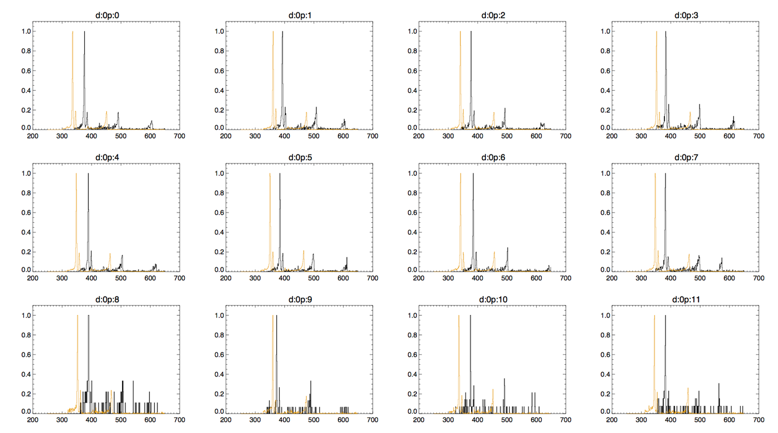

Figure : Quicklook calibration spectra for all pixels for Detector ID 1. In black is the spectrum measured during Run 215 in gold is the spectrum measured during the ground TVAC tests. As the durations are significantly different the maximum value for each spectrum is scaled to 1.0 in each pixel. N.B. Although the indices for detector (d) and pixel (p) both start from 0 detectors are conventionally numbered from 1 to 32.

#### Construction Of Second ELUT

One of the purposes of the first in flight calibration run was to aid in the rapid generation of an updated ELUT as the version which was initially on board was uploaded before launch and was constructed based on data taken in the lab under potentially significantly different conditions. Initial comparisons between positions of the calibration lines in the first in-flight run and the data used to construct the initial ELUT suggested that the detectors were running under a different set of parameters as there were many notable differences between the positions of the lines for each pixel.

An ELUT was constructed in the first hours of NECP 1 using the calibration data from the first in-flight calibration. In order to make this rapid estimation a full fit for all lines in all 384 detector pixels was not performed but an estimate made using the locations of the strongest calibration lines.

The offset and gain parameters for the new ELUT (elut_table_20200414) were compared with those of the previously uploaded table (elut_table_20190704): Figures Figure 2 - Figure 5.

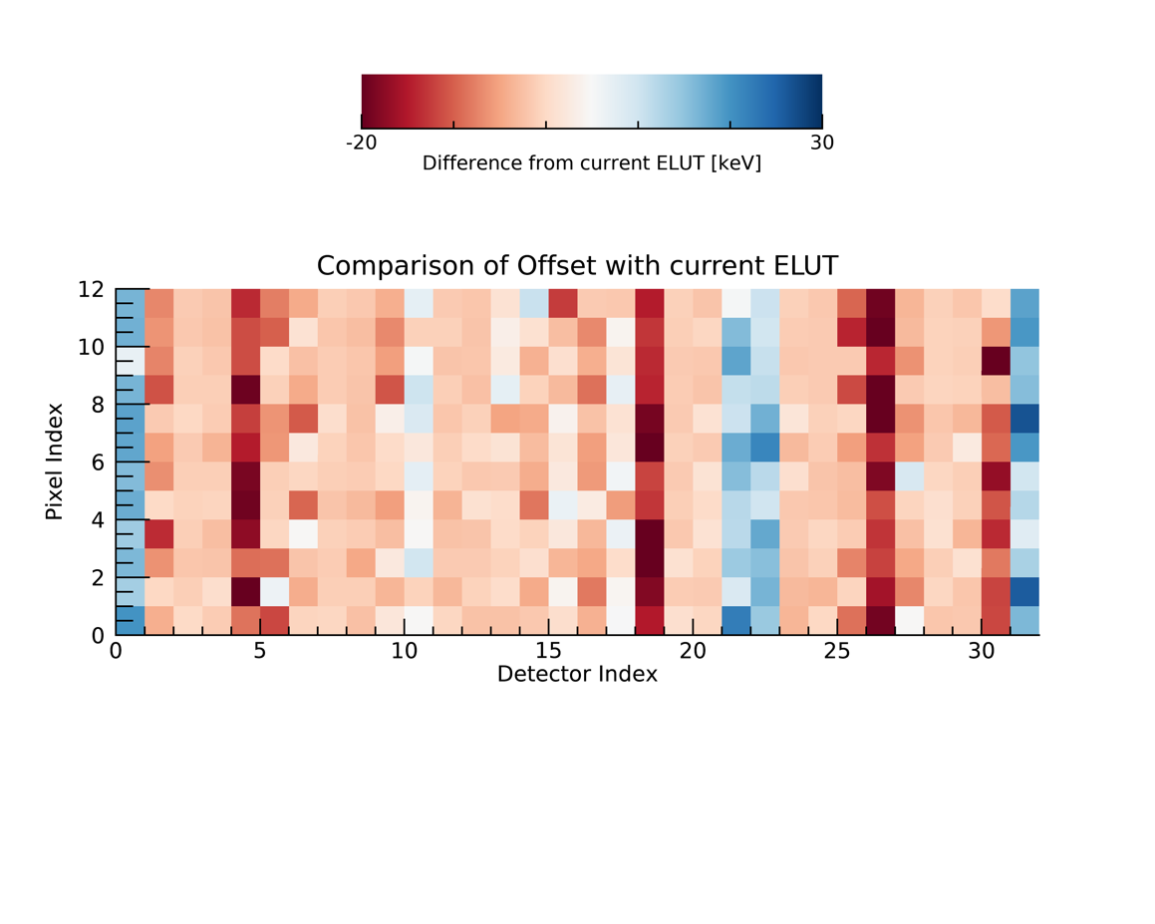

Figure : The difference in offset for each detector pixel between the measurements used to construct the ELUTs elut_table_20190704 and elut_table_20200414

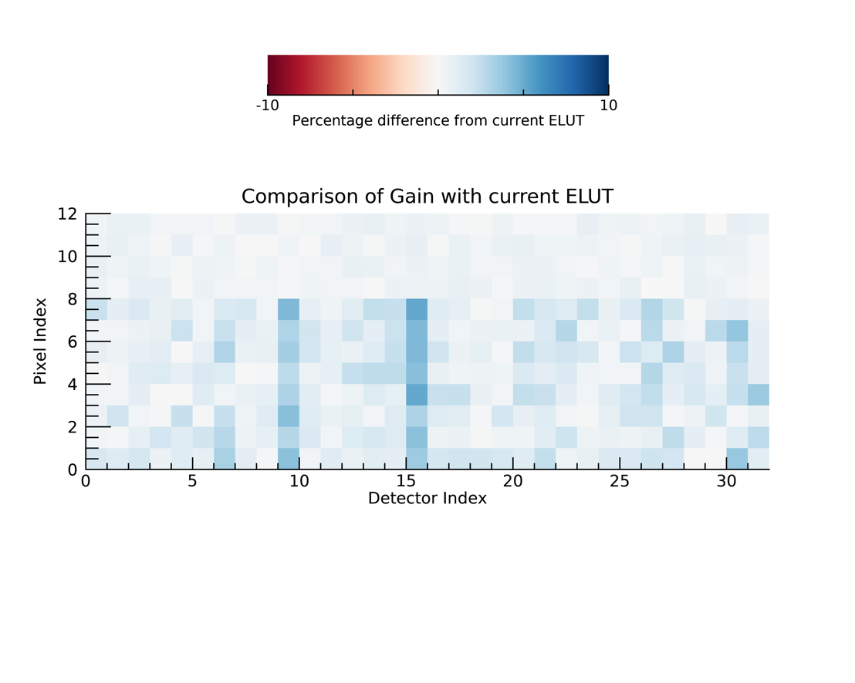

Figure : The difference in gain for each detector pixel between the measurements used to construct the ELUTs elut_table_20190704 and elut_table_20200414

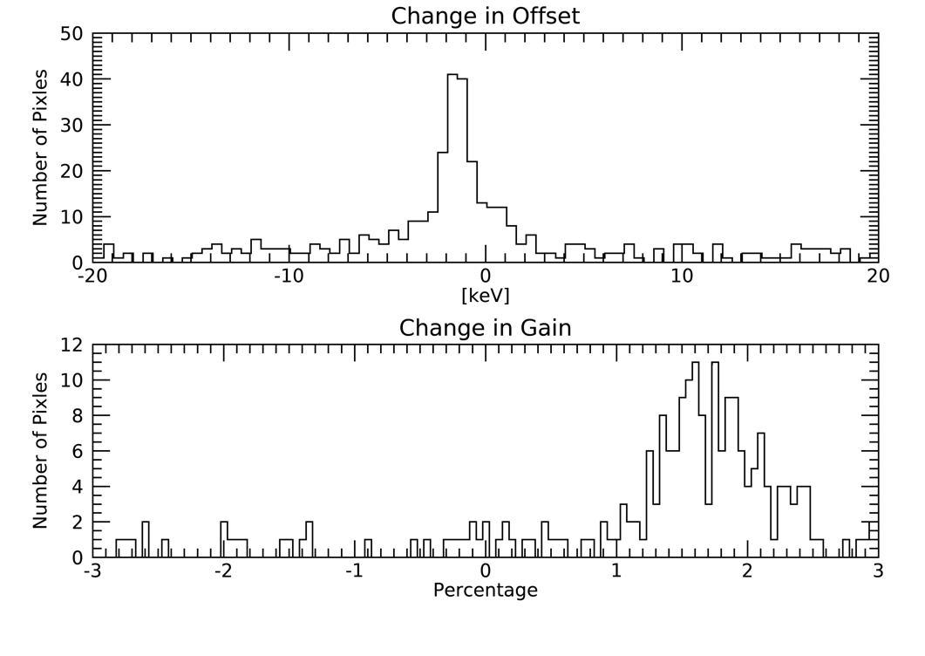

Figure : Histograms over all detector pixels showing the difference in offset (top) and gain (bottom) between the measurements used to construct the ELUTs elut_table_20190704 and elut_table_20200414

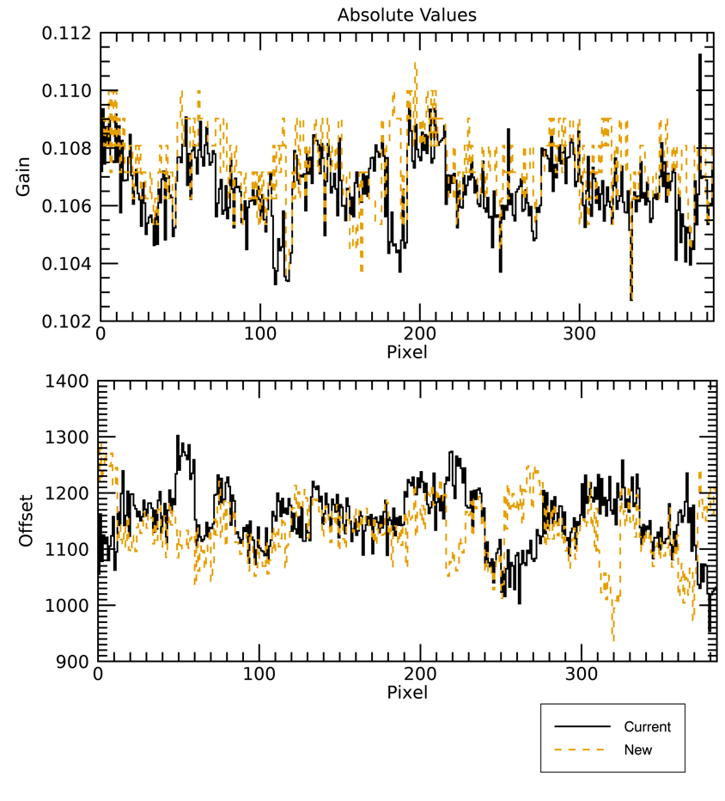

Figure : Plot showing the estimated value of offset (top) and gain (bottom) for all detector pixels used to construct the ELUTs elut_table_20190704 (black, solid) and elut_table_20200414 (gold, dotted)

## First Overnight Calibration Run

#### Calibration run 236

|  |  |
| --- | --- |
| Start UTC | 2020-04-14T17:05:06 |
| Duration | 43200 s |
| Live time | 21727.137 s |
| Subspectrum 0 | [0,1024] step= 1 |

Table : Parameters for first overnight calibration run.

As it is important to obtain a large number of counts for reasonable statistics to reliably fit the calibration lines and their associated parameters, particularly for the small pixels, longer duration runs are necessary. In normal operations calibration runs will last for roughly a day though counts will only be recorded while the count rate is low. During the commissioning there are many different parameters being tested so it is not appropriate to have the calibration spectra accumulated for long durations in the background as changes to the detector parameters will distort the spectrum. During the interactive commissioning windows there are periods when Solar Orbiter is not in contact with the ground and so STIX can be left running in Nominal mode with the calibration data accumulating without interference.

#### First Overnight ELUT comparison

The higher count statistics data from the first overnight were analysed by CEA to robustly identify the gains and offsets needed to produce an updated ELUT table. Particular attention was paid to the small pixels as their significantly lower area means that even for longer durations the counts are low and the shapes of the calibration lines less well defined.

The gain and offset parameters for this calibration run analysis match closely with those derived from the initial calibration run. This suggests that the initial rough estimates were reasonable and that the detector calibration is stable over the timescale of days. Figure 6 - Figure 9.

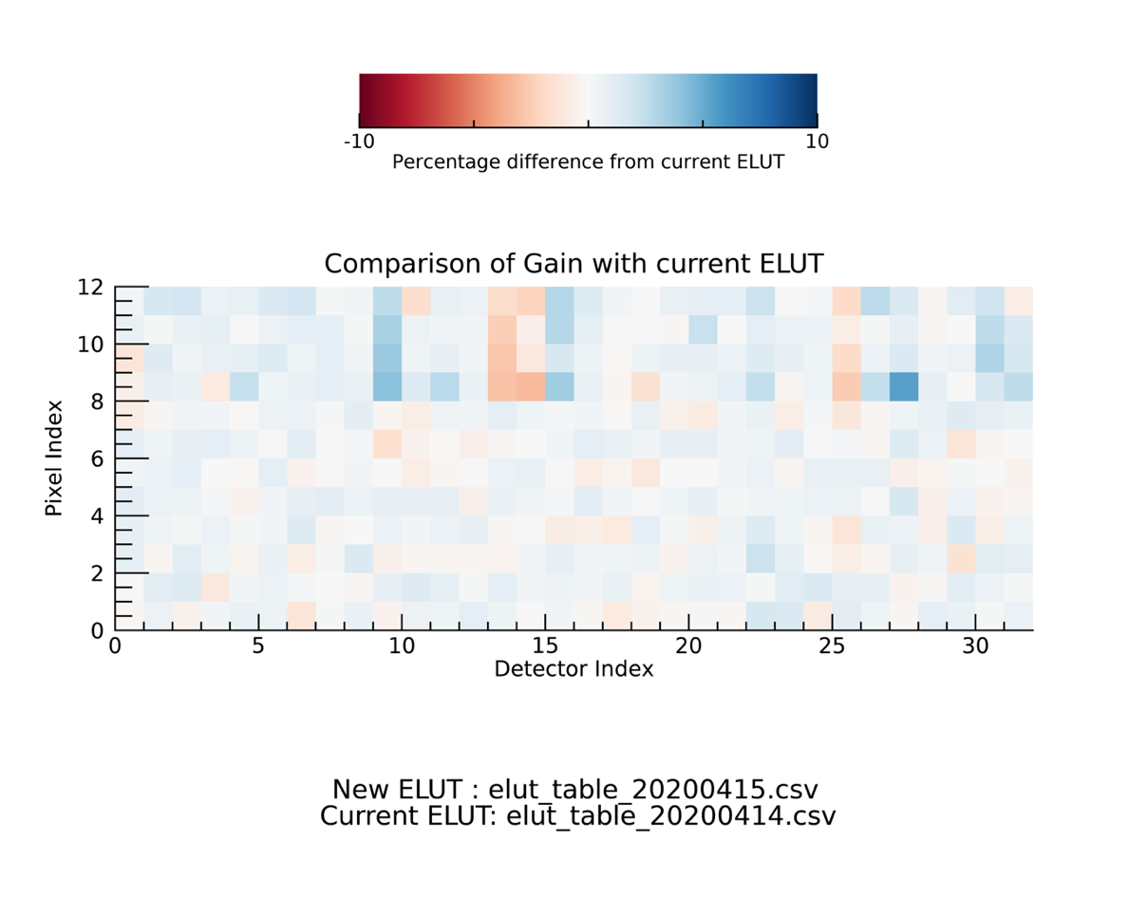

Figure :The difference in offset for each detector pixel between the measurements used to construct the ELUTs elut_table_20200414 and elut_table_20200415

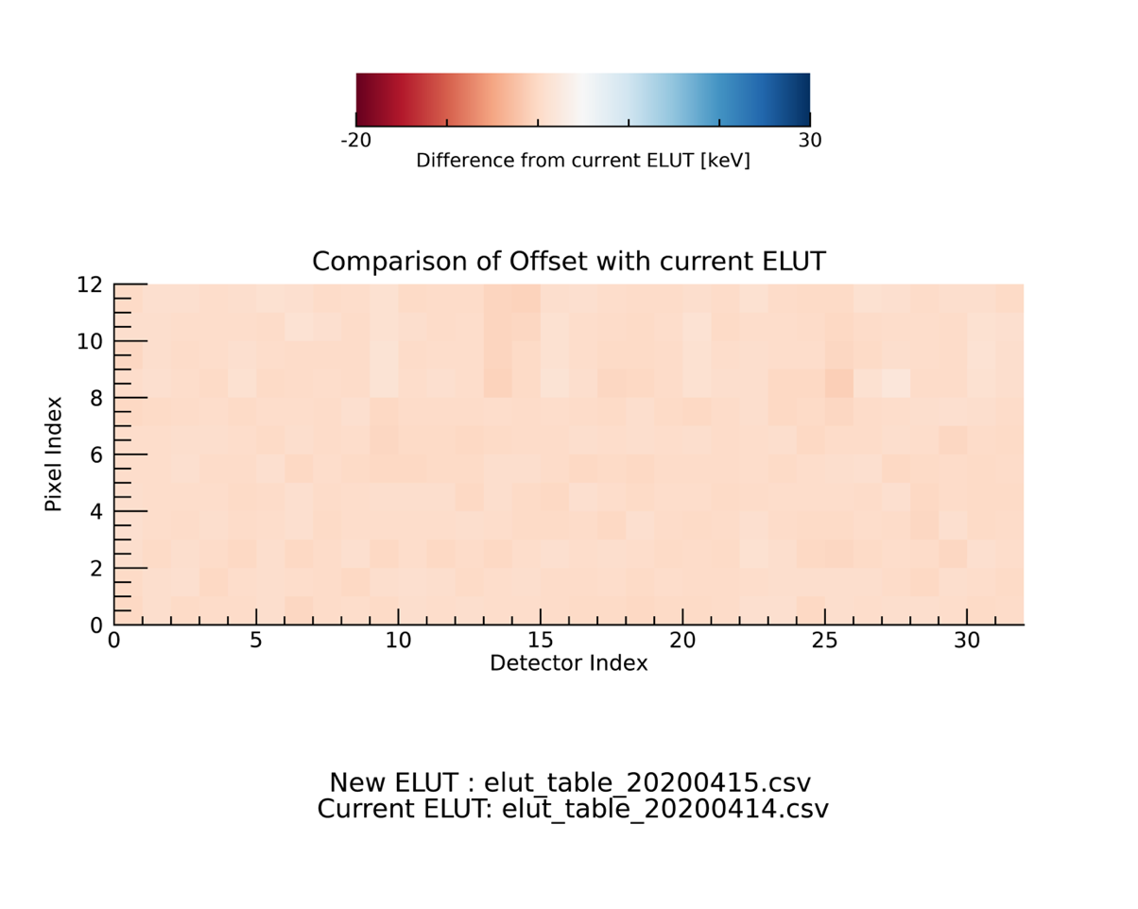

Figure The difference in gain for each detector pixel between the measurements used to construct the ELUTs elut_table_20200414 and elut_table_20200415

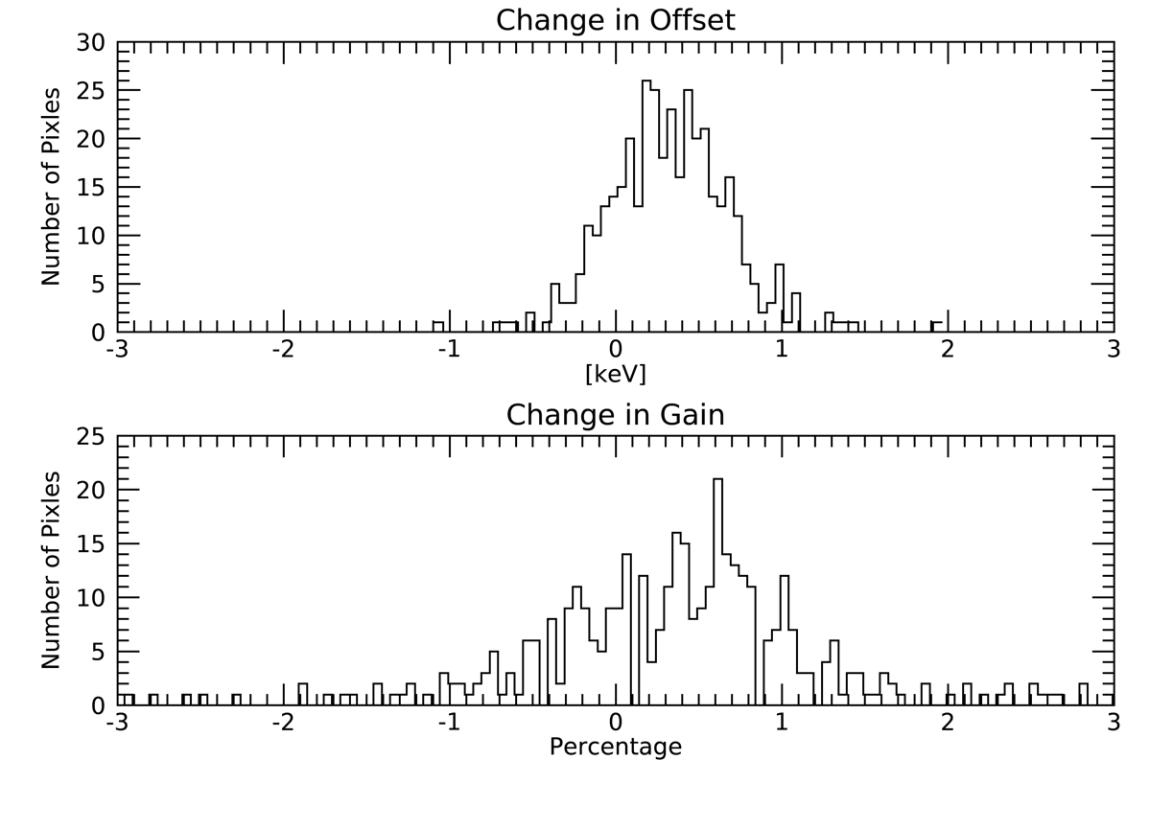

Figure :Histograms over all detector pixels showing the difference in offset (top) and gain (bottom) between the measurements used to construct the ELUTs elut_table_20200414 and elut_table_20200415

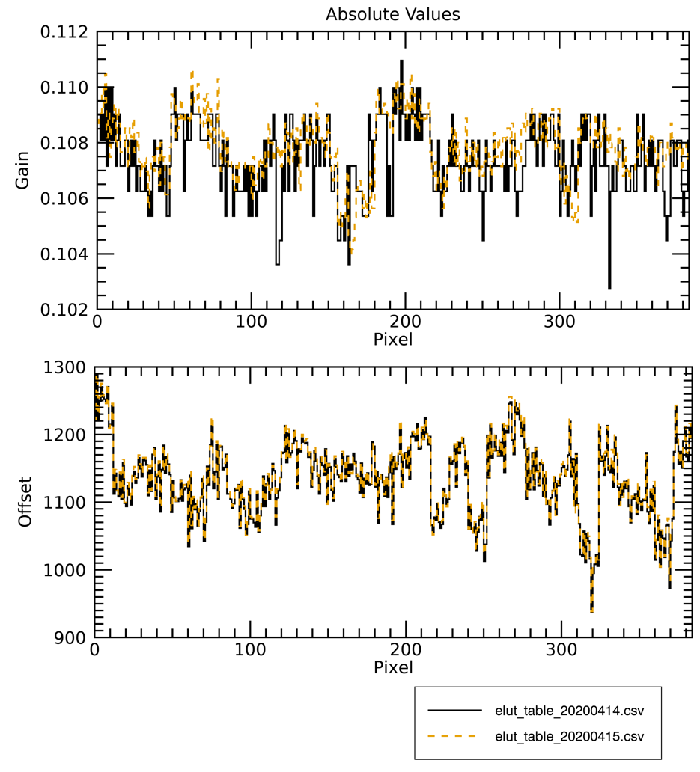

Figure : Plot showing the estimated value of offset (top) and gain (bottom) for all detector pixels used to construct the ELUTs elut_table_20200414 (black, solid) and elut_table_20200415 (gold, dotted)

### High Energy Bump

When analysing the early runs of the calibration spectra it was quickly noticed that all spectra contained a peak at ADC values corresponding to a moderately high photon energy. These features occurred at different values for each detector the location of which did not correspond with the gain and offset of the detector. CEA is still studying the cause but it is not considered significant and can be treated like a stable background component for each pixel with cause unknown. Importantly, the rates of this component scale with the calibration source rates and won’t change during flare measurements.

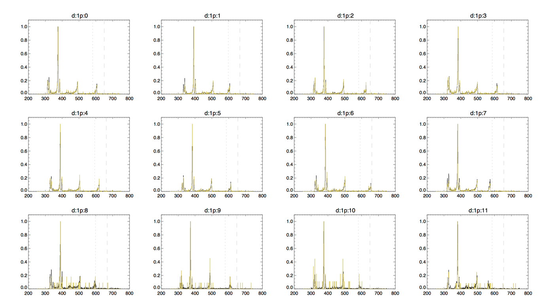

Figure : Calibration spectra for all pixels of Detector ID 1 showing consistency of high energy feature for two runs. The approximate location of the high energy feature is indicated by the dotted and dashed lines.

### Calibration variation over several Temperature cycles

It was quickly identified from the first bulk science spectrogram data that there were oscillations in the count rates in the lower science energy bins and that the correlated well with the detector temperature. The large variation with temperature for certain energy bins is caused by calibration lines shifting over the energy edge with the change in temperature and so being recorded in adjacent bins at different points in the temperature cycle.



Figure : Plot showing the counts in the 6 -7 keV energy bin (black) and the detector temperature (ºC) at the same time.

The ELUT characterizes the mapping between the measured ADC channel and the photon energy and is expected to be constant over long durations. As the telemetry requirement for the ELUT is moderate it is preferable that a new version is uploaded infrequently. As was observed with the initial spectrogram data changes in the calibration can also occur due to the variation of detector temperature. The flight software therefore has the capability to account for these variations on board using a separate temperature look up table (TLUT).

### Calibration including baseline holder

As the temperature variations meant that it was preferable to run STIX with the baseline holder on which reduces the effect of the change in temperature on the energy calibration a new ELUT had to be constructed. The spectra used to calculate the gains and offsets were created by summing a large number of short duration calibration runs under the condition with the baseline holder on.

In order to better characterise how changes in temperature affect the energy calibration measuring the positions of the lines at different temperatures was necessary. There is a trade-off between having a longer duration which is needed to get sufficient counts to accurately measure the line positions and not wanting the runs to cover too large a range in temperature so the positions as a function of temperature can be determined. Segments of duration 15 minutes running over night which should capture the temperature cycle at many different points were selected.

The feasibility of applying a TLUT to the current temperature calibration variations was investigated. It was determined that over the temperature cycles currently experienced by STIX at this point in the mission the shifts were barely detectable, at most 1 ADC channel. Therefore, with the baseline holder on, applying a TLUT would not lead to an improvement in energy calibration. The detector temperature variations will be constantly monitored and if they become large enough that applying a TLUT will lead to a measurable difference or if it is decided to run STIX with the baseline holder off the application of the TLUT will be revisited.

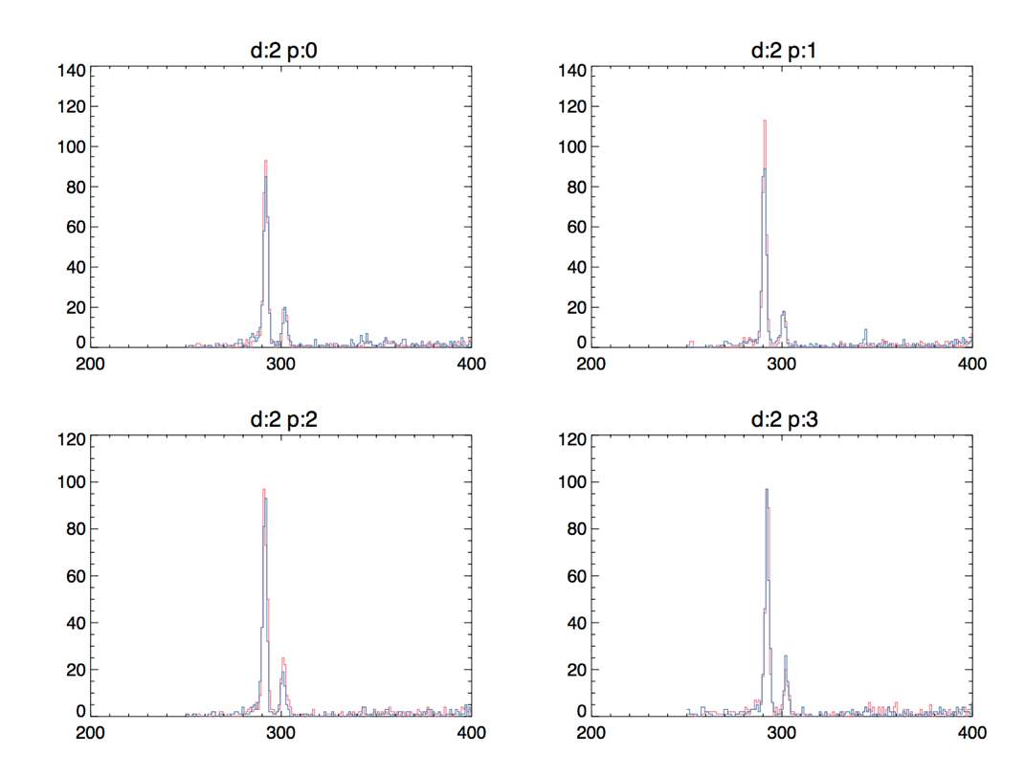

Figure : Comparison of locations for calibration peaks corresponding to the highest (red) and lowest (blue) temperature segments during the overnight calibration runs on 7th May 2020.

### Bandwidth Optimisation

The processing on board allows the division of each calibration spectrum into up to 8 sub-spectra which different resolutions in terms of summed ADC channels over different ranges. All initial low latency calibration spectra were telemetered at the full resolution of 1024 bins each corresponding to roughly 0.4 keV

#### Updated bandwidth estimates

The objectives of sub-spectral formatting are:

i) to reduce the needed telemetry for the calibration spectra so that it can fit within the overall QL telemetry budget limits

ii) to provide high resolution measurements around the strongest calibration lines so that good fits can be performed which allow the extraction of detector parameters

iii) to include the full spectrum at lower resolution to provide an overview and allow tracking of any features

iv) to allow enough large enough margins to account for shifts over time or due to temperature

v) to have these subspectral parameters such that the fewest number of groups of detectors with each set of parameters can be used.

As a rough estimate based on the total quicklook telemetry budget 260 data points per spectrum per pixel.

The first attempt to fulfil these objectives divides the detectors into two groups which have different ranges for the desired high-resolution range around the calibration line (Figure 13, Table 3Table 4). A range of 20 – 90 keV was selected to provide adequate coverage of the 31 and 81 keV lines with a significant buffer to account for moderate changes in the calibration over time. The channels below that are summed in steps of 2 so that there is still reasonable estimation of the calibration spectrum around the threshold. At the higher end from 90 keV to the maximum ADC channels the spectrum is more coarsely binned in steps of 26.

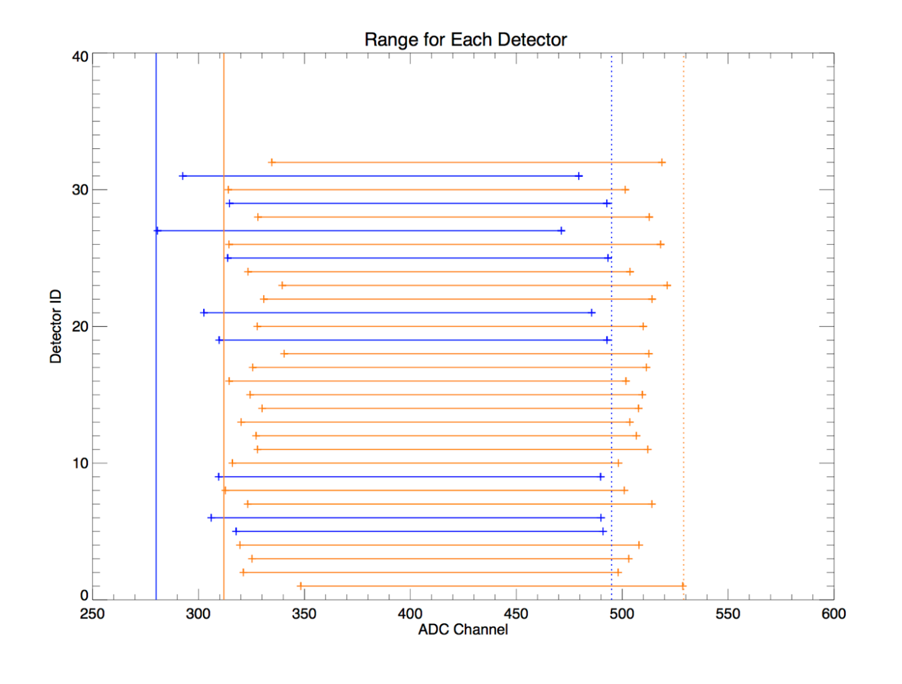

Figure : Two groups of detectors with different ADC ranges for full resolution binning

|  |  |  |  |  |  |  |  |  |  |  |  |
| --- | --- | --- | --- | --- | --- | --- | --- | --- | --- | --- | --- |
|  |  |  |  |  |  |  |  |  |  |  |  |
| Subspectrum |  | Number of Spectral Points -1 | Summed channels per point -1 | Lowest Channel |  |  | from | to | channels/point |  |
|  |  |  |  |  |  |  |  |  |  |  |
|  |  | PIX00217 | PIX00218 | PIX00219 |  |  |  |  |  |  |  | |
| 1 |  | 22 | 1 | 234 |  |  | 234 | 279 | 2 |  |  | | |  |
|  |  |  |  |  |  |  |  |  |  |  |  | | |  |
|  |  | PIX00220 | PIX00221 | PIX00222 |  |  |  |  |  |  |  | | |  |
| 2 |  | 223 | 0 | 280 |  |  | 280 | 503 | 1 |  |  | | |  |
|  |  |  |  |  |  |  |  |  |  |  |  | | |  |
|  |  | PIX00223 | PIX00224 | PIX00225 |  |  |  |  |  |  |  | | |  |
| 3 |  | 19 | 25 | 504 |  |  | 504 | 1023 | 26 |  |  | | |  |
|  |  |  |  |  |  |  |  |  |  |  |  | | |  |
|  |  |  |  |  |  |  |  |  |  |  |  | | |  |
|  |  |  |  |  |  |  |  |  |  |  |  | | |  |
| Subspectrum mask | PIX00251 | 0x001F |  |  |  |  |  |  |  |  |  | | |  |
| Detector mask | PIX00248 |  | detectors | 1 4 5 7 8 9 15 18 20 24 26 | | | | | | |  | | |  |
| PixeL mask | PIX00249 | 0x0FFF |  | 28 29 30 | |  |  |  |  |  |  | | |  |
|  |  |  |  |  |  |  |  |  |  |  |  | | |  |

Table : Subspectral parameters for first bandwidth optimised group

Total summed spectral points = 267

|  |  |  |  |  |  |  |  |  |  |  |  |  |  |
| --- | --- | --- | --- | --- | --- | --- | --- | --- | --- | --- | --- | --- | --- |
|  |  |  |  |  |  |  |  |  |  |  | |  |  |
| Subspectrum |  | Number of Spectral Points -1 | Summed channels per point -1 | Lowest Channel |  |  | from | to | channels/point |  |
|  |  |  |  |  |  |  |  |  |  |  |
|  |  | PIX00217 | PIX00218 | PIX00219 |  |  |  |  |  |  | |  |  |
| 1 |  | 23 | 1 | 266 |  |  | 266 | 313 | 2 |  | |  |  |
|  |  |  |  |  |  |  |  |  |  |  | |  |  |
|  |  | PIX00220 | PIX00221 | PIX00222 |  |  |  |  |  |  | |  |  |
| 2 |  | 215 | 0 | 314 |  |  | 314 | 529 | 1 |  | |  |  |
|  |  |  |  |  |  |  |  |  |  |  | |  |  |
|  |  | PIX00223 | PIX00224 | PIX00225 |  |  |  |  |  |  | |  |  |
| 3 |  | 18 | 25 | 530 |  |  | 530 | 1023 | 26 |  | |  |  |
|  |  |  |  |  |  |  |  |  |  |  | |  |  |
|  |  |  |  |  |  |  |  |  |  |  | |  |  |
|  |  |  |  |  |  |  |  |  |  |  | |  |  |
| Subspectrum mask | PIX00251 | 0x001F |  |  |  |  |  |  |  |  | |  |  |
| Detector mask | PIX00248 |  | detectors | 0 2 3 6 10 11 12 13 14 16 17 | | | | | | | |  |  |
| PixeL mask | PIX00249 | 0x0FFF |  | 19 21 22 23 25 27 31 | | | | |  |  | |  |  |
|  |  |  |  |  |  |  |  |  |  |  | |  |  |

Table : Subspectral parameters for second bandwidth optimised group

Total summed spectral points = 259

#### Revised current parameters with current FSW

The current implementation of the STIX flight software does not have the capability to separate the subspectrum parameters by detector. Therefore, a new set was needed which would cover the desired high-resolution range for all detectors (Table 5). This set goes from ACD channel 0 up to 20 keV for the lowest detector. Again, at the high end the spectrum is coarsely binned in steps of 26 from 90keV on the highest detector up to the maximum ADC channel. This naturally requires additional bandwidth of 292 summed spectral points per calibration spectrum.

|  |  |  |  |  |  |  |  |  |  |
| --- | --- | --- | --- | --- | --- | --- | --- | --- | --- |
|  |  |  |  |  |  |  |  |  |  |
|  |  |  |  |  |  |  |  |  |  |  |  |
| Subspectrum |  | Number of Spectral Points -1 | Summed channels per point -1 | Lowest Channel |  |  | from | to | channels/point |  |
|  |  |  |  |  |  |  |  |  |  |  |  | | |
|  |  | PIX00217 | PIX00218 | PIX00219 |  |  |  |  |  |  |  | |  |
| 1 |  | 22 | 1 | 234 |  |  | 234 | 279 | 2 |  |  | |  |
|  |  |  |  |  |  |  |  |  |  |  |  | |  |
|  |  | PIX00220 | PIX00221 | PIX00222 |  |  |  |  |  |  |  | |  |
| 2 |  | 249 | 0 | 280 |  |  | 280 | 529 | 1 |  |  | |  |
|  |  |  |  |  |  |  |  |  |  |  |  | |  |
|  |  | PIX00223 | PIX00224 | PIX00225 |  |  |  |  |  |  |  | |  |
| 3 |  | 18 | 25 | 530 |  |  | 530 | 1023 | 26 |  |  | |  |
|  |  |  |  |  |  |  |  |  |  |  |  | |  |
|  |  |  |  |  |  |  |  |  |  |  |  | |  |
|  |  |  |  |  |  |  |  |  |  |  |  | |  |
| Subspectrum mask | PIX00251 | 0x0007 |  |  |  |  |  |  |  |  |  | |  |
| Detector mask | PIX00248 | 0xFFFFFFFF |  |  |  |  |  |  |  |  |  | |  |
| PixeL mask | PIX00249 | 0x0FFF |  |  |  |  |  |  |  |  |  | |  |

Table : Subspectral parameters for single bandwidth reduced group covering all detectors with baseline holder off

Total summed spectral points 292

#### Bandwidth with Baseline holder on

As the calibration parameters are different when the baseline holder is switched on a new set of optimal subspectra must be calculated for this case (Table 6). This was again done for one set of parameters which encompasses all detectors. As the baseline holder on tends to result in the calibration lines occurring at more similar ADC values across detectors the total number of points per calibration spectrum with this scheme is 250.

|  |  |  |  |  |  |  |  |  |  |
| --- | --- | --- | --- | --- | --- | --- | --- | --- | --- |
|  |  |  |  |  |  |  |  |  |  |
|  |  |  |  |  |  |  |  |  |  |  |  | |
| Subspectrum |  | Number of Spectral Points -1 | Summed channels per point -1 | Lowest Channel |  |  | from | to | channels/point |  |
|  |  |  |  |  |  |  |  |  |  |  |
|  |  | PIX00217 | PIX00218 | PIX00219 |  |  |  |  |  |  |  |
| 1 |  | 24 | 1 | 200 |  |  | 200 | 249 | 2 |  |  |
|  |  |  |  |  |  |  |  |  |  |  |  |
|  |  | PIX00220 | PIX00221 | PIX00222 |  |  |  |  |  |  |  | | |  |
| 2 |  | 200 | 0 | 250 |  |  | 250 | 450 | 1 |  |  | | |  |
|  |  |  |  |  |  |  |  |  |  |  |  | | |  |
|  |  | PIX00223 | PIX00224 | PIX00225 |  |  |  |  |  |  |  | | |  |
| 3 |  | 23 | 23 | 450 |  |  | 450 | 1024 | 24* |  |  | | |  |
|  |  |  |  |  |  |  |  |  |  |  |  | | |  |
|  |  |  |  |  |  |  |  |  |  |  |  | | |  |
|  |  |  |  |  |  |  |  |  |  |  |  | | |  |
| Subspectrum mask | PIX00251 | 0x0007 |  |  |  |  |  |  |  |  |  | | |  |
| Detector mask | PIX00248 | 0xFFFFFFFF |  |  |  |  |  |  |  |  |  | | |  |
| PixeL mask | PIX00249 | 0x0FFF |  |  |  |  |  |  |  |  |  | | |  |

*N.B. The last group in subspectrum 3 will only have 22 points.

Table : Subspectral parameters for single bandwidth reduced group covering all detectors with baseline holder on

## Appendix 1: All Spectra for Initial Calibration Run



Figure : As Figure 1 from Detector 1 Pixel 0 to Detector 3 Pixel 7



Figure 15: As Figure 1 from Detector 3 Pixel 8 to Detector 6 Pixel 3



Figure 16: As Figure 1 from Detector 6 Pixel 4 to Detector 8 Pixel 11



Figure 17: As Figure 1 from Detector 9 Pixel 0 to Detector 11 Pixel 7



Figure 18: As Figure 1 from Detector 11 Pixel 8 to Detector 14 Pixel 3



Figure 19: As Figure 1 from Detector 14 Pixel 4 to Detector 16 Pixel 11



Figure 20: As Figure 1 from Detector 17 Pixel 0 to Detector 19 Pixel 7



Figure 21: As Figure 1 from Detector 19 Pixel 8 to Detector 22 Pixel 3



Figure 22: As Figure 1 from Detector 22 Pixel 4 to Detector 24 Pixel 11



Figure 23: As Figure 1 from Detector 25 Pixel 0 to Detector 27 Pixel 7



Figure 24: As Figure 1 from Detector 27 Pixel 8 to Detector 30 Pixel 3



Figure 25: As Figure 1 from Detector 30 Pixel 4 to Detector 32 Pixel 11